Mutual Learning Workshop
With a Little Help from My Friends

‘What is better than to learn from colleagues about such a sensitive issue as quality assurance’ says Radu Pulbere from the University of Arts & Design in Cluj-Napoca, Romania. At the Mutual Learning Workshop 7 and 8 September 2006 in Budapest Radu Pulbere, will report about his experience with the self-evaluation school visit, currently carried out by a group of colleagues from across Europe. Other experts will speak, discuss and facilitate sessions.

Higher arts education institutes in all arts disciplines from Hungary, Romania, Czech Republic, Croatia, Serbia, Slovakia, Slovenia, Ukraine and Austria are kindly invited to participate in this workshop and to nominate delegates from their institution.
For the first 20 delegates from arts institutions in the invited countries, participation is without costs and the hotel costs for maximum 2 nights will be paid by inter}artes. Selection will take place on the basis of a written motivation.

For other participants the conference fee is 50 EURO.
Participation is limited to 40 persons.

The Mutual Learning Workshop offers:
- First hand exchange of experience from the self-evaluation school visit
- Practical training in quality assurance, learning outcomes and ECTS
- Exchange about shared characteristics and competences of Dance, Design, Fine Art and Theatre Education
- Updates on Bologna developments, inter}artes and Tuning project.

Nominations can be sent in by email to Lars Ebert at lars@inter-artes.org or fax 0031-877 875 344.

Go to www.inter-artes.org for updated information about the workshop and the provisional programme. Please contact Lars Ebert at lars@inter-artes.org for further information. Contact person at the Hungarian University of Fine Arts, Budapest is Eszter Lázár, leszter@mke.hu.

We hope to meet you in Budapest!

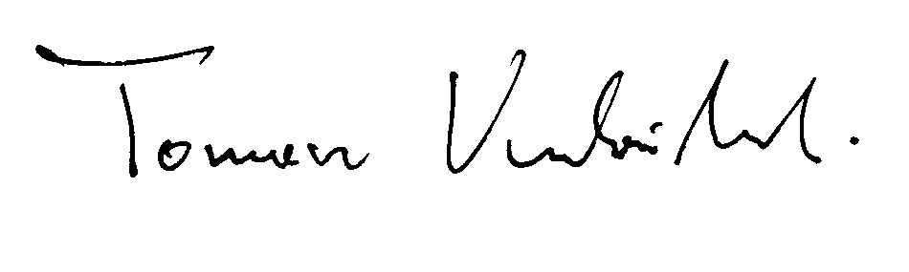
Tomasz Kubikowski,
Chair Steering Group inter}artes
Provisional Programme

Thursday 7 September 2006
14.00 – 15.00 | Arrival and Registration
15.00 – 15.15 | Welcome by rector of University and inter-artes chair Tomasz Kubikowski (AZSTA, Wasaw)
15.15 – 16.00 | Brief Introduction on quality assurance/enhancement and Bologna developments (John Butler UCE, Birmingham)
16.00 – 17.00 | Experience from the self-evaluation school visit to Cluj-Napoca (Radu Pulbere, Chancelor of the UAD Cluj-Napoca)
17.00 – 18.00 | Round table with all participating countries on Quality Assurance and Enhancement (Kieran Corcoran, DIT, Dublin)
20.00 hours | Joint Dinner
Friday 8 September 2006
9.30 – 10.00 | Brief Introduction on Learning Outcomes (Francisco Beja, IPL, Porto)Brief Introduction on Quality Assurance (John Butler, UCE Birmingham)
10.00 – 12.00 | Workshops on defining Learning Outcomes/Competences. Presentation of the TUNING document (Paula Crabtree, KIB, Bergen and Bob Baker, Limerick)
12.00 – 13.00 | Brief Introduction on Quality Assurance (John Butler, UCE Birmingham)
13.00 – 14.00 | Lunch
14.00 – 16.00 | Workshop on Quality Assurance and Enhancement
16.00 – 17.00 | Closing Session chaired by Truus Ophuysen, inter}artes
17.00 | Tour through academy buildings and studios
18.00 – 20.00 | Guided tour Jewish district

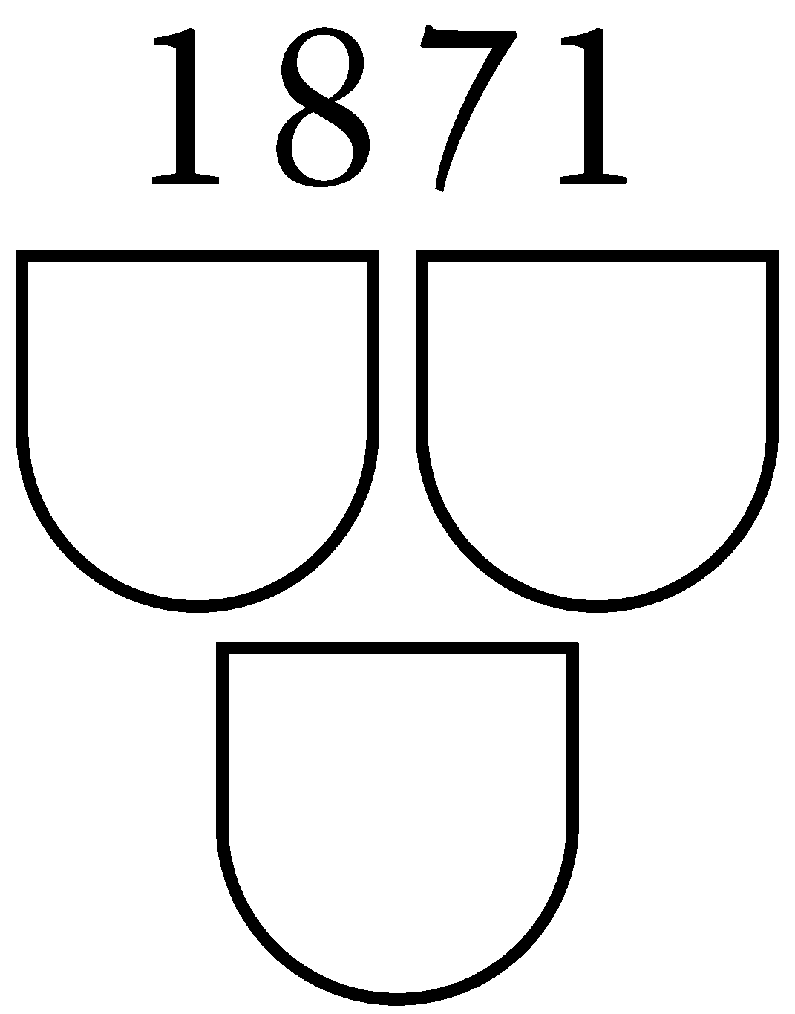
About the hosting institution

Founded in 1871, The Hungarian University of Fine Arts is the oldest fine art higher education institute in Hungary. The central building is located at the most elegant avenue of Pest, connecting the Danube with the City Park. Another main site where studios are located is Epreskert (Mulberry Garden), which inherited its
name from the mulberry trees in the area. The five-year course leads to an MA degree in painting, sculpture, graphics, graphic design, intermedia, scenography
or conservation. A three-year doctoral course is also offered. The University has 400 enrolled students. Please see www.mke.hu/english/index.php for more information.

